Kubernetes Task -02

Pre-requisite For doing YAML in VS Code:
The reason for doing this is we won't have any difficulty while writing the new script in .yaml files.

Download yaml extension in vs code
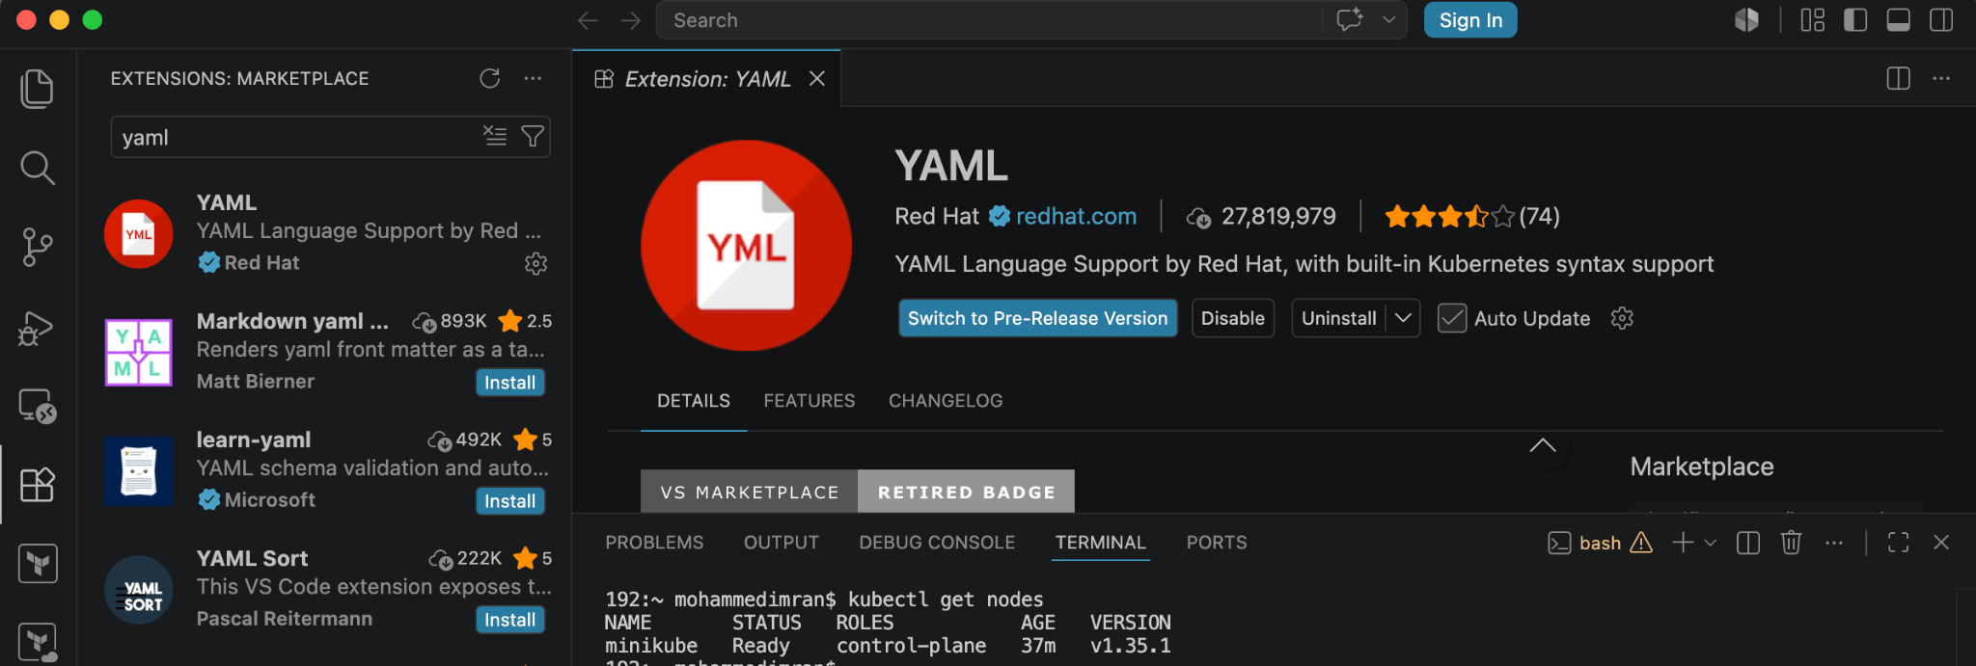
Now goto extension settings⇒
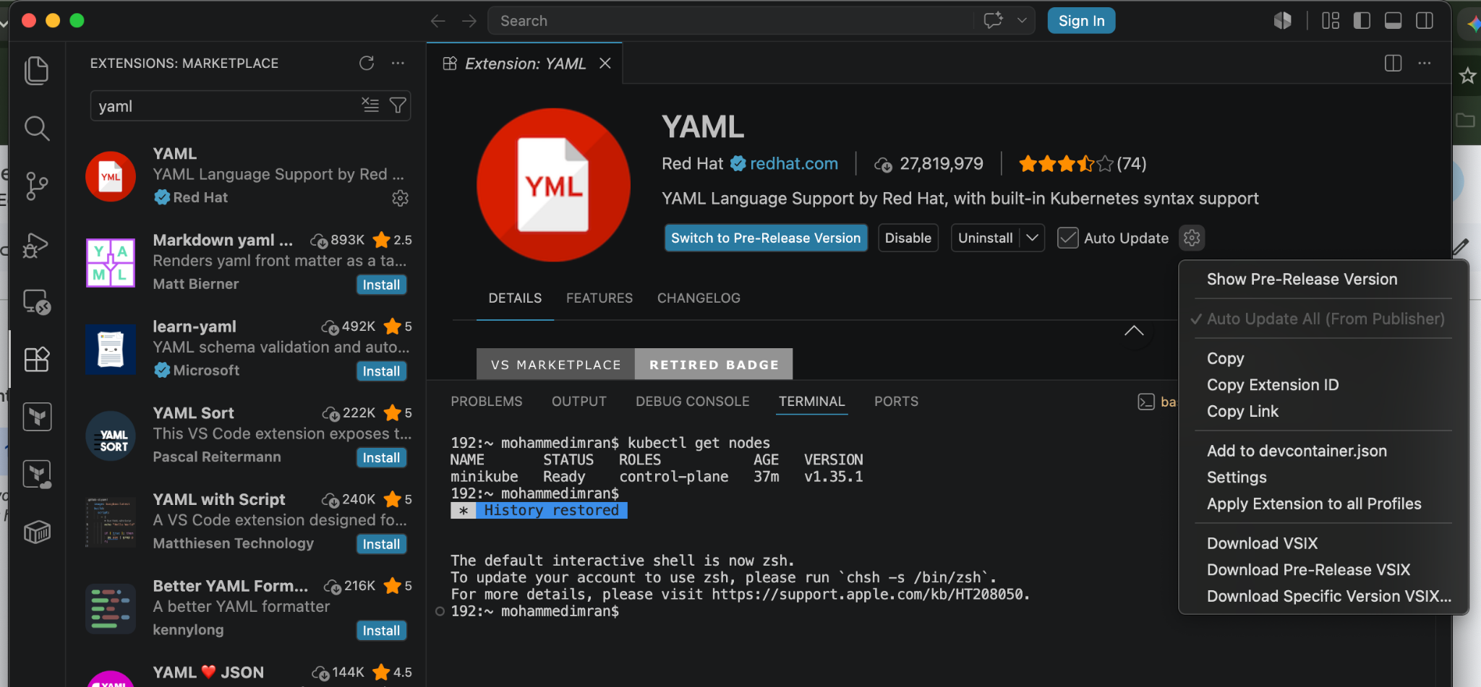

goto extension settings⇒edit in settings.json⇒
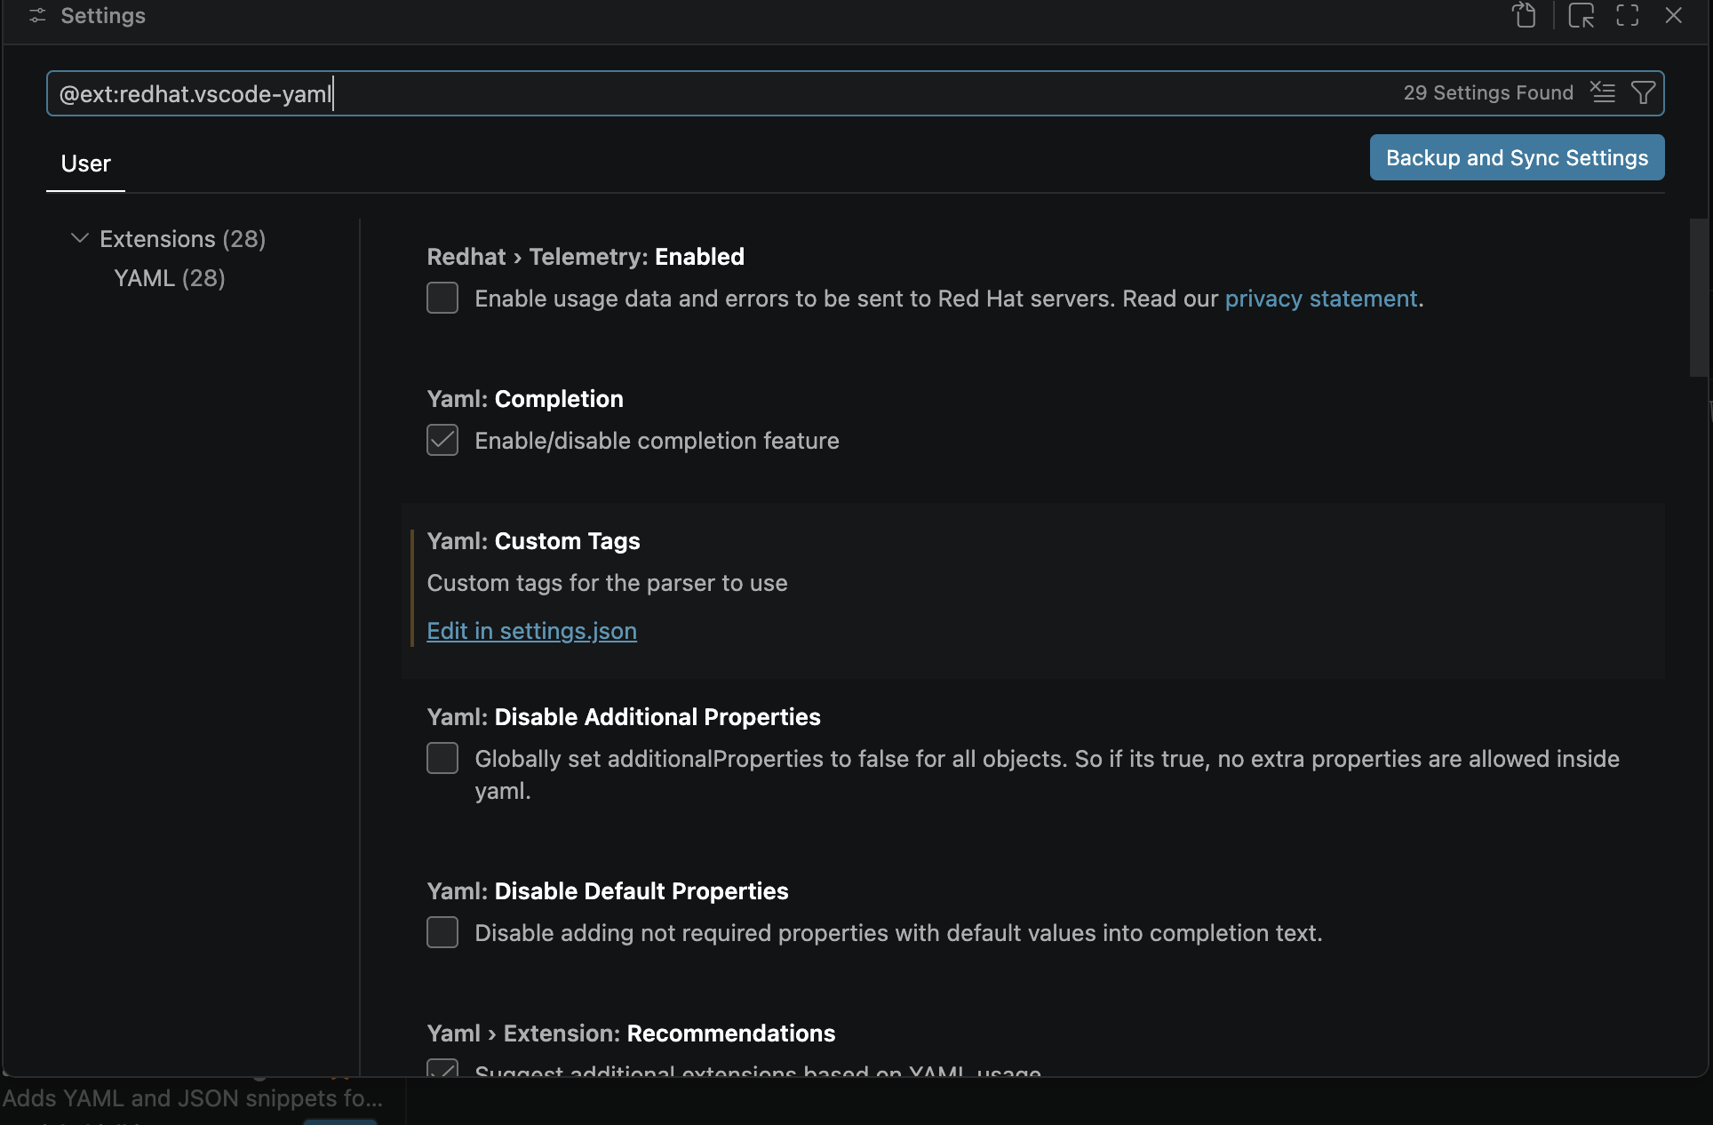
goto extension settings⇒edit in settings.json⇒edit the json script⇒save⇒close and open vs code.
{
"files.autoSave": "afterDelay",
"yaml.schemas": {
"Kubernetes": "*.yaml"
},
"yaml.customTags": [

],
"[python]": {
"editor.formatOnType": true
}
}

The use of the above script is if we are writing any kubernetes script it will automatically pull the syntax in our .yaml files

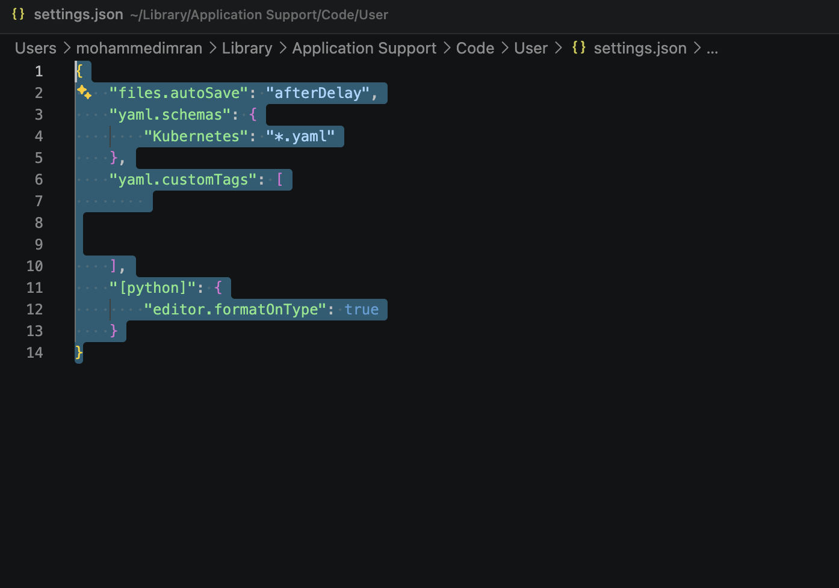

For writing a .yaml file we can check in our node using a command
kubectl explain pods⇒ it will be giving us what to write inside the yaml file, like all the details.

- Create a Simple Pod Using YAML Task: Write a YAML file to create a Pod named firstpod with an nginx container. Verify the Pod creation using kubectl get pods and check the logs of the container using kubectl logs firstpod.

What is a Pod?
A Pod is the smallest deployable unit in Kubernetes.
A Pod usually contains:
- One container (common case)
- OR multiple tightly coupled containers
Think of a Pod as a wrapper around containers.
In this task, we create a Pod running an Nginx web server using the Docker image from Docker Hub.
Vi firstpod.yaml

apiVersion: v1
kind: Pod
metadata:
name: firstpod
spec:
containers:
- name: nginx-container
image: nginx
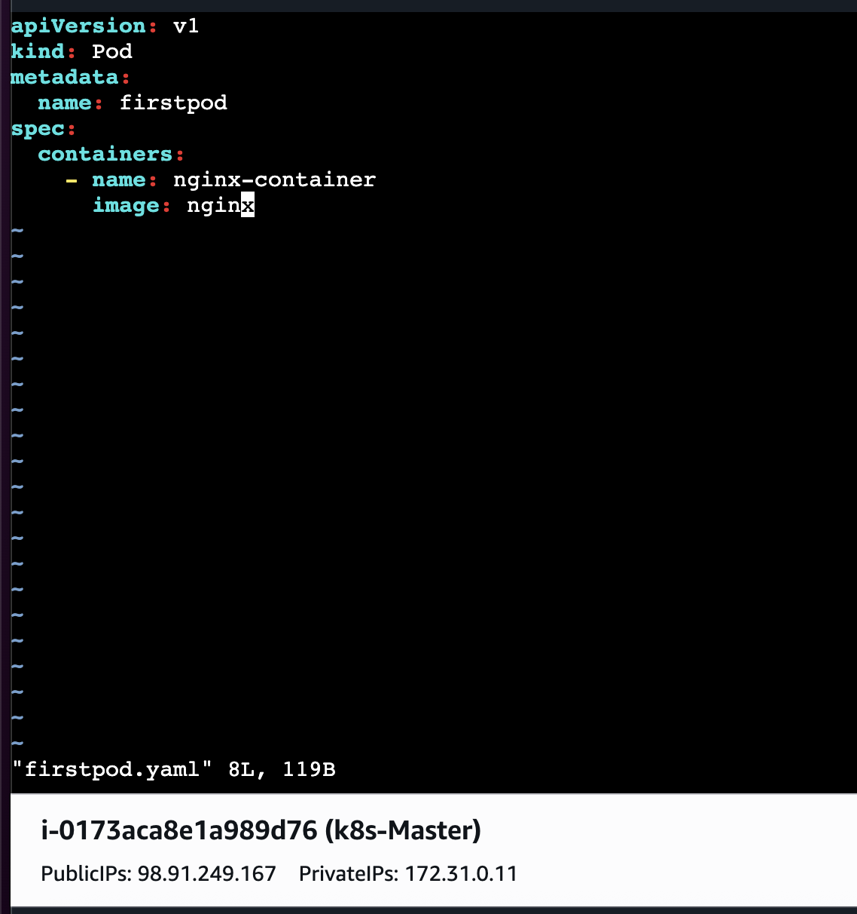

Now lets Deploy
kubectl apply -f firstpod.yaml
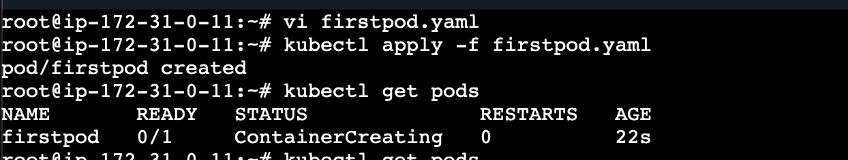
And verify
kubectl get pods

check the logs of the container using kubectl logs firstpod.
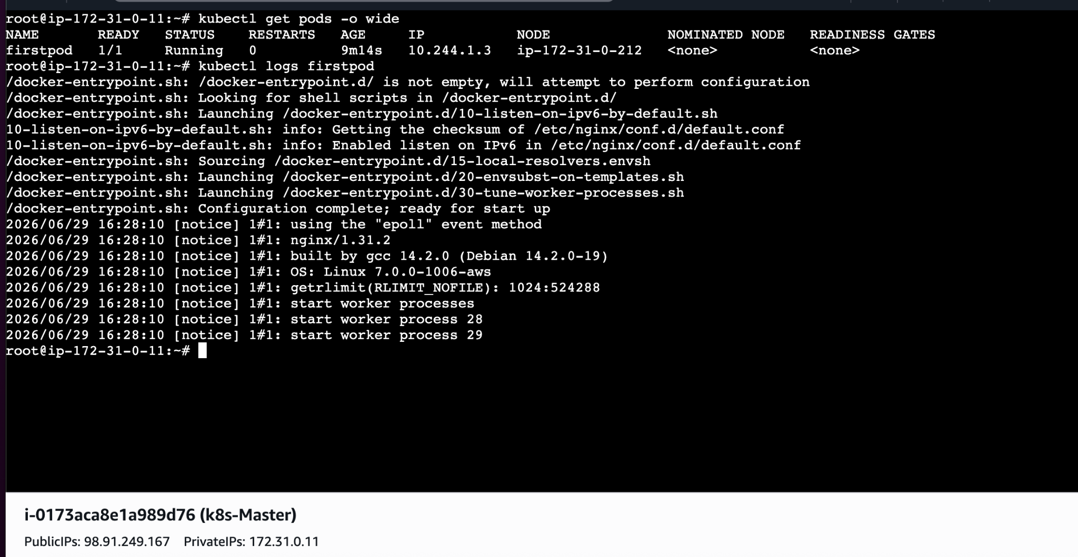
- Set Environment Variables in a Pod Task: Modify the YAML file to include environment variables myname: sabair and City: Hyderabad. Deploy the Pod and use kubectl exec <pod_name> -- env to check if the environment variables are set properly.

What are Environment Variables?
Environment variables are key-value pairs passed to the container.
Example:
APP_ENV=PROD
Applications use them for:
- DB credentials
- region
- API URLs
- Configuration

Create and insert the below data in vi envpod.yaml

apiVersion: v1
kind: Pod
metadata:
name: envpod
spec:
containers:
- name: nginx
image: nginx
env:
- name: myname
value: "sabair"
- name: City
value: "Hyderabad"
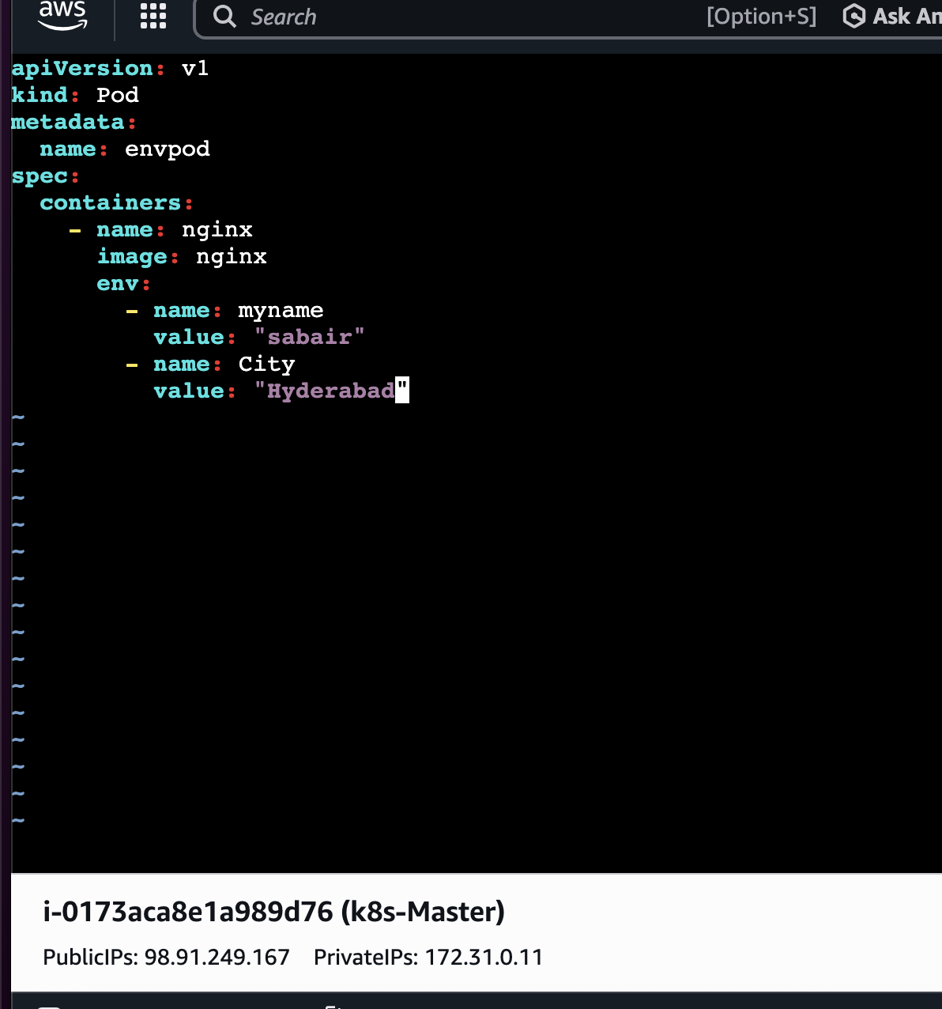

Deploy⇒ kubectl apply -f envpod.yaml
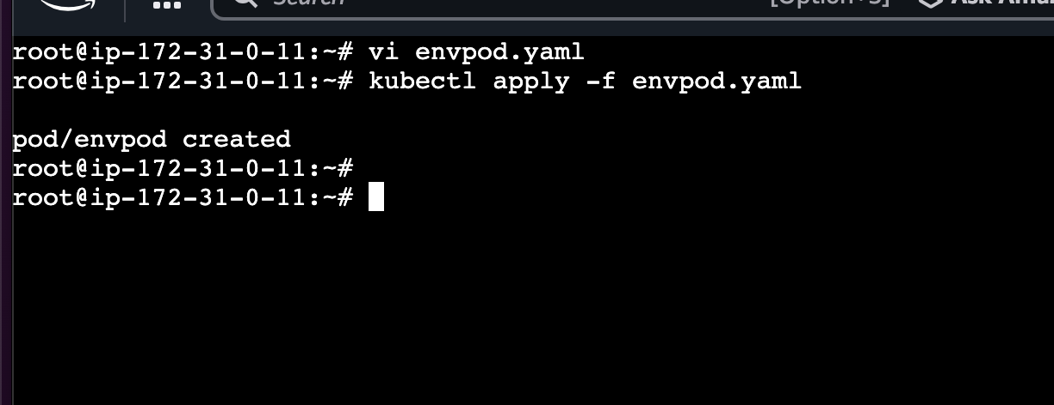

Verify ⇒kubectl exec envpod -- env
Explanation:
exec
Runs command inside container.
env
Linux command to print environment variables.
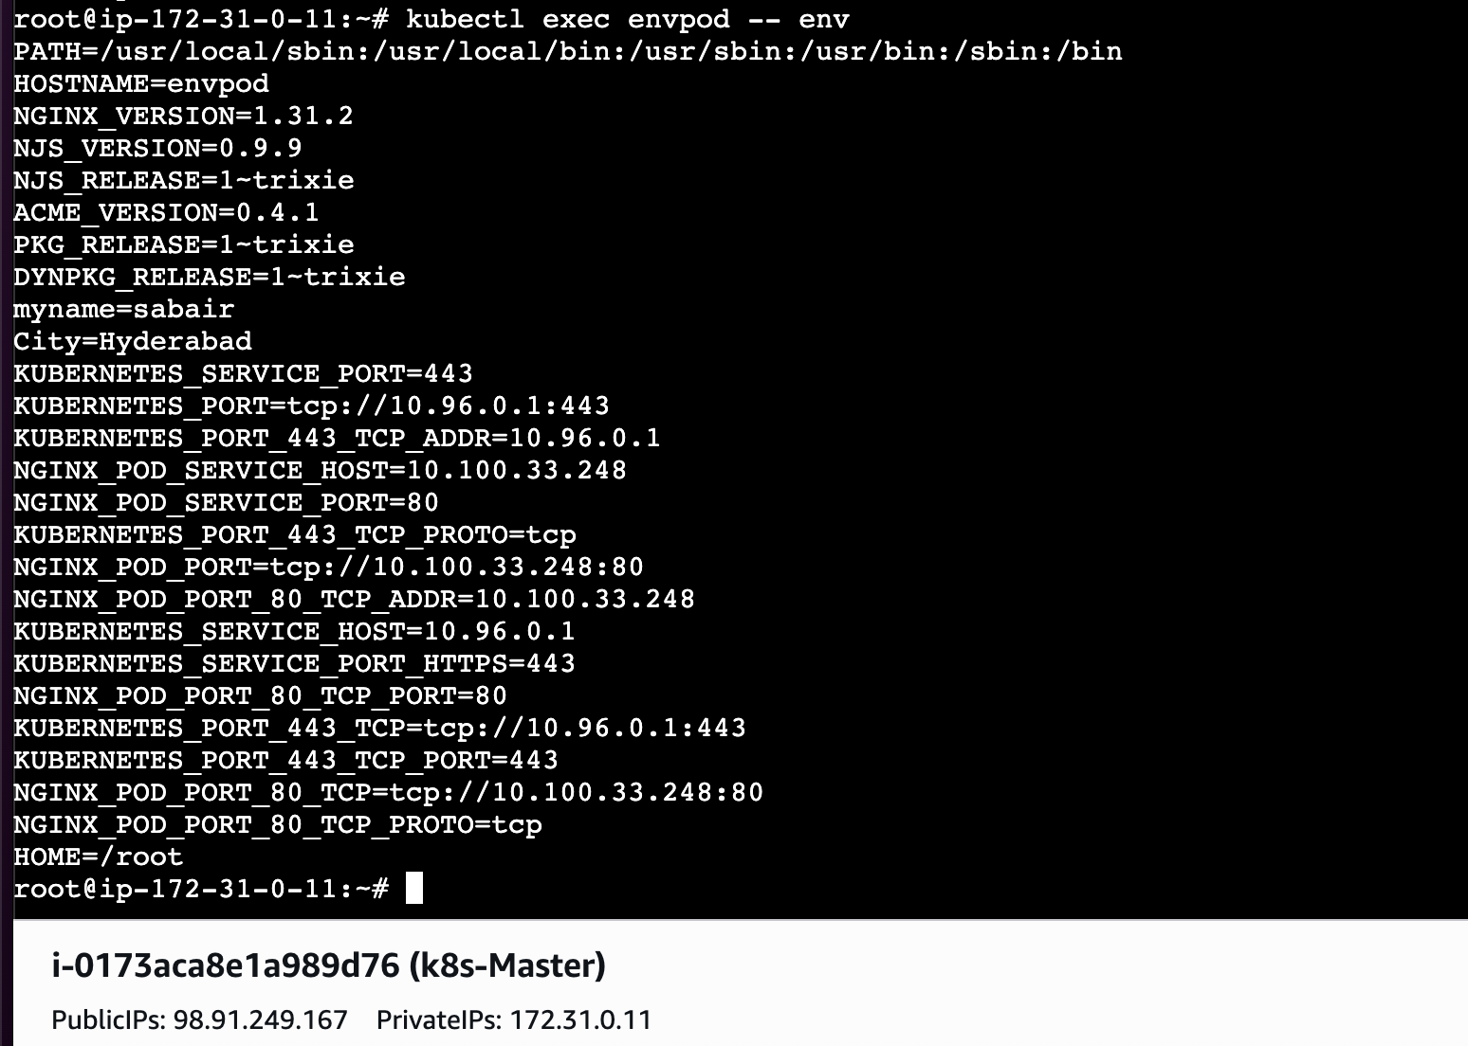

- Deploy a Pod with Commands (Args) in YAML Task: Modify the YAML file to add args that instruct the container to sleep for 50 seconds. Deploy the Pod and use kubectl describe pod to verify the args are correctly passed to the container.

Sometimes we don’t want default container behavior.We override startup command.
Create ⇒ vi sleeppod.yaml
apiVersion: v1
kind: Pod
metadata:
name: sleep-pod
spec:
containers:
- name: sleeper
image: busybox
args: ["sleep", "50"]

Why Busybox?
BusyBox is a lightweight Linux image containing shell utilities.
Useful for testing.

args
args:
Arguments passed to container entrypoint.
Command becomes:
sleep 50
Meaning:
sleep for 50 seconds.

Why use args?
Used when:
- delay startup
- run script
- debug containers
- 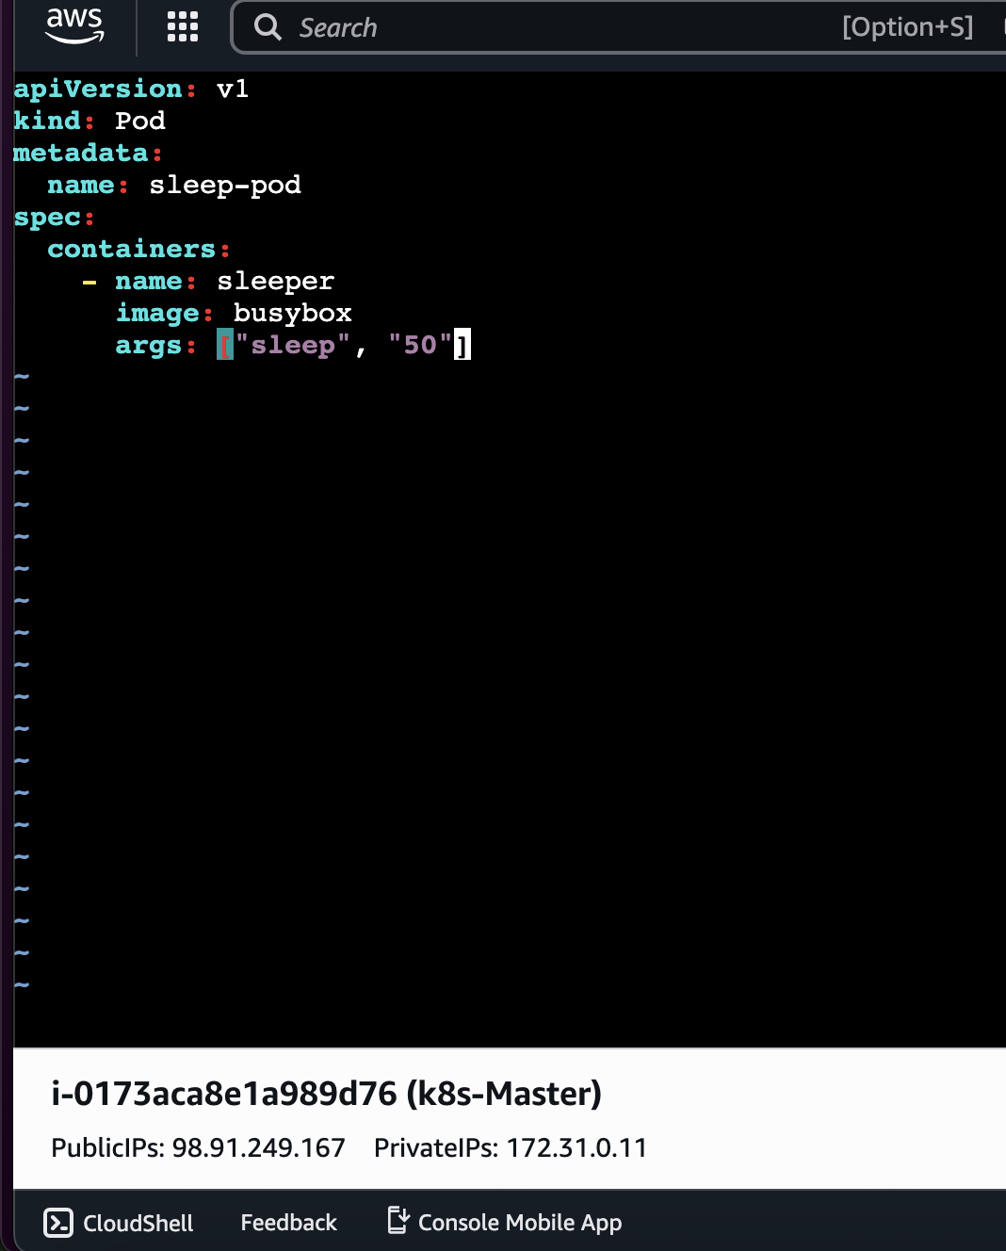
Deploy ⇒kubectl apply -f sleep-pod.yaml
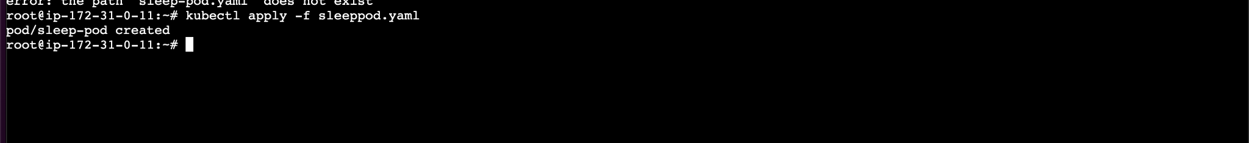
Verify ⇒ kubectl describe pod sleep-pod
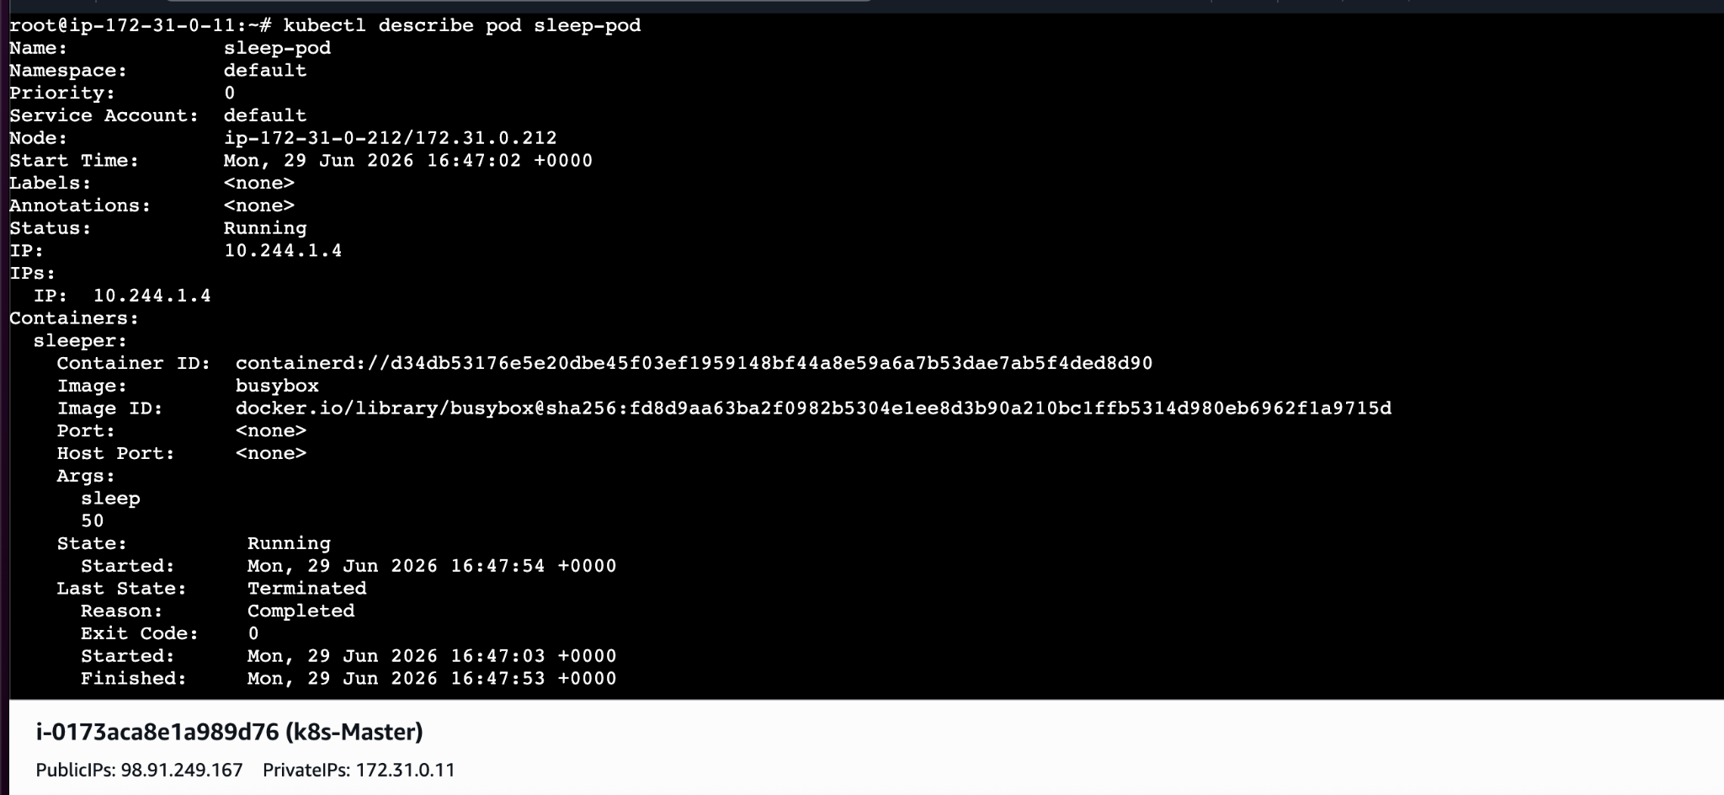
- Create a Pod with Two Containers Task: Create a YAML file to define a Pod with two nginx containers inside. Use kubectl exec to access both containers and verify that both containers can communicate through the same network (e.g., using telnet between them).
This is called a Multi-container Pod.
Use when containers need to work closely.
Example:
- app container
- logging sidecar
- proxy container
apiVersion: v1
kind: Pod
metadata:
name: multi-pod
spec:
containers:
- name: nginx1
image: nginx

- name: nginx2
image: nginx
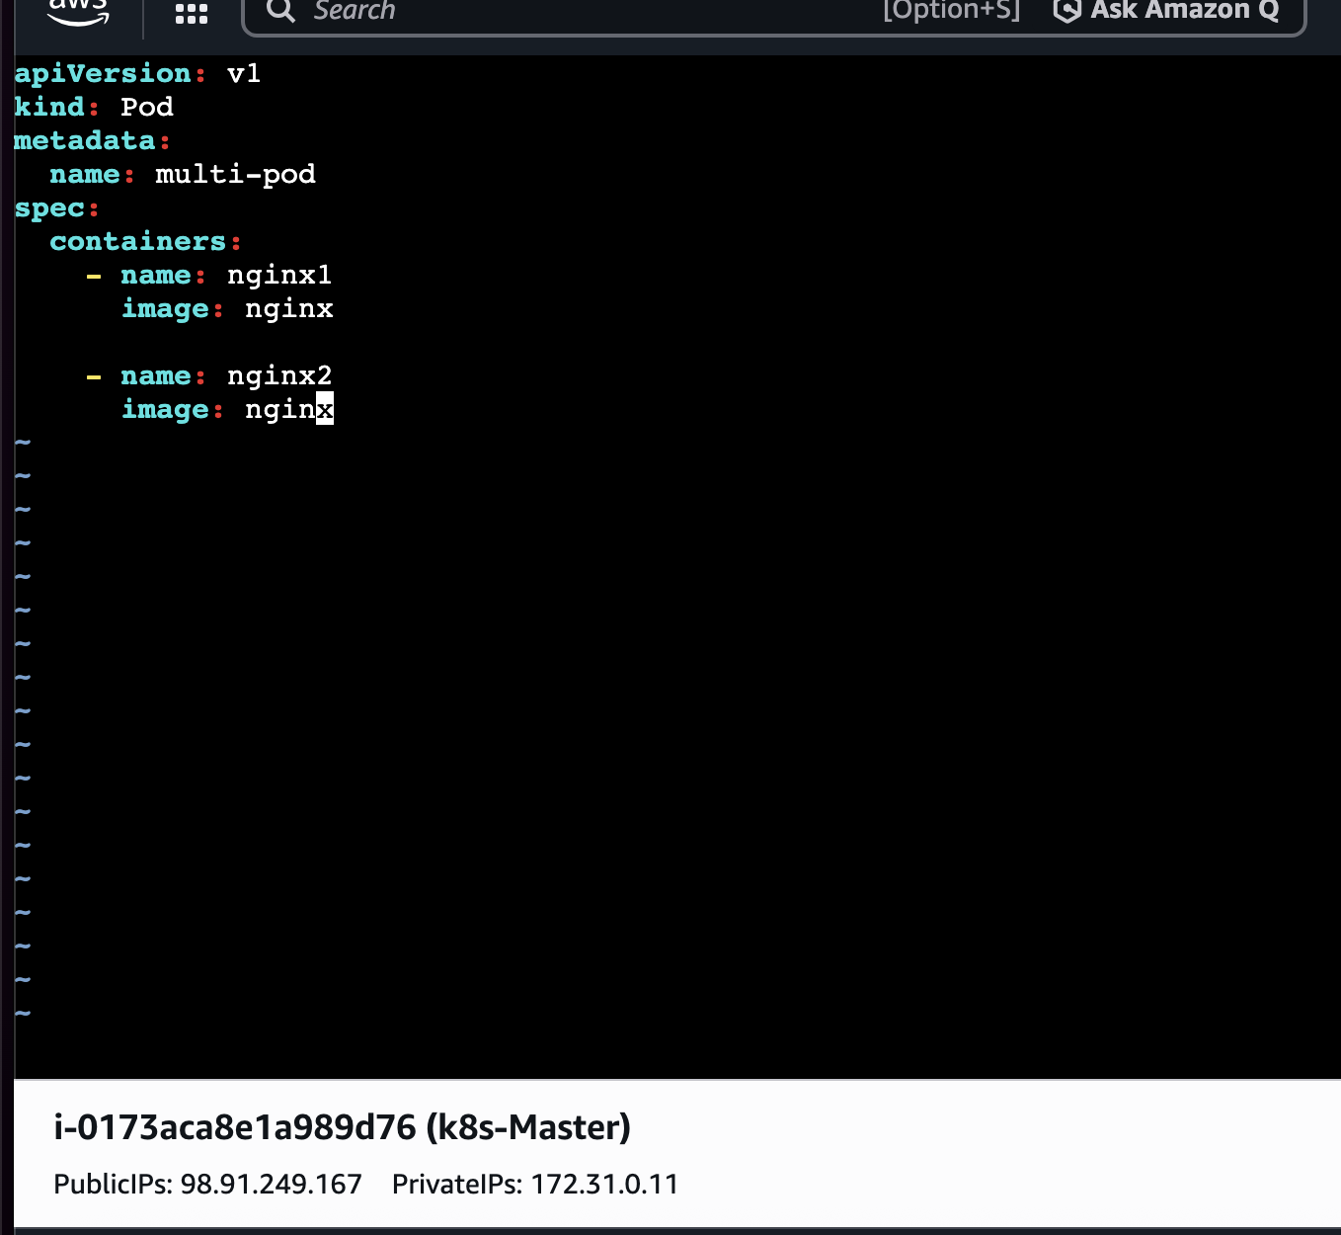
Deploy ⇒ kubectl apply -f multi-pod.yaml
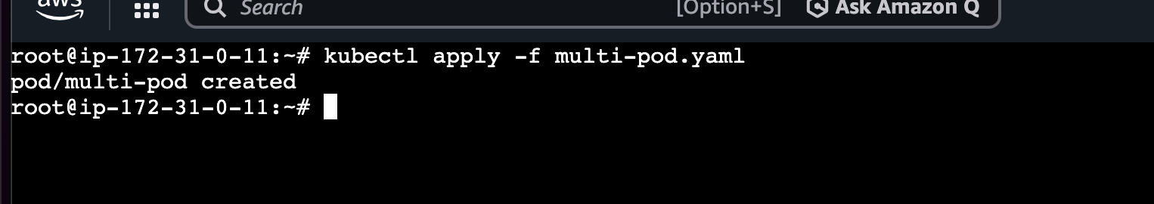
Containers in same Pod share:

Network
Same IP address

Storage
Can share volumes

localhost
Can talk via localhost

Lets see if we can access the ⇒ container 1

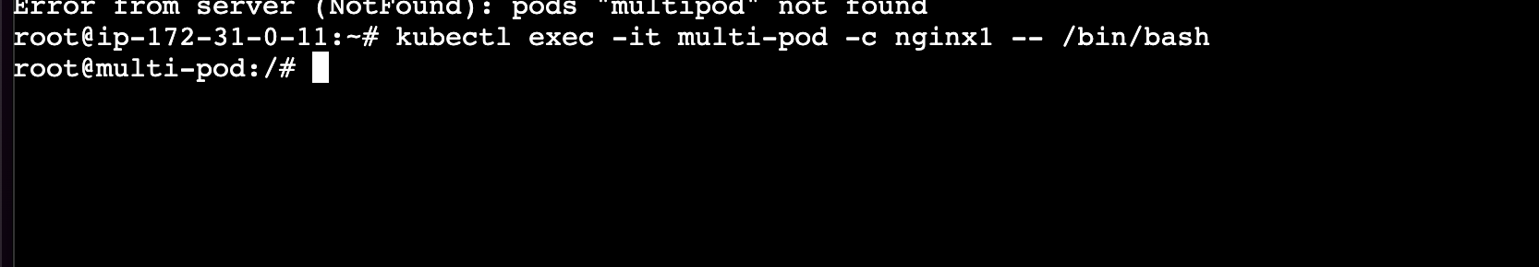

Lets Test communication
Inside container:
curl localhost
You should get the Nginx page.
Because both containers share a Pod network.
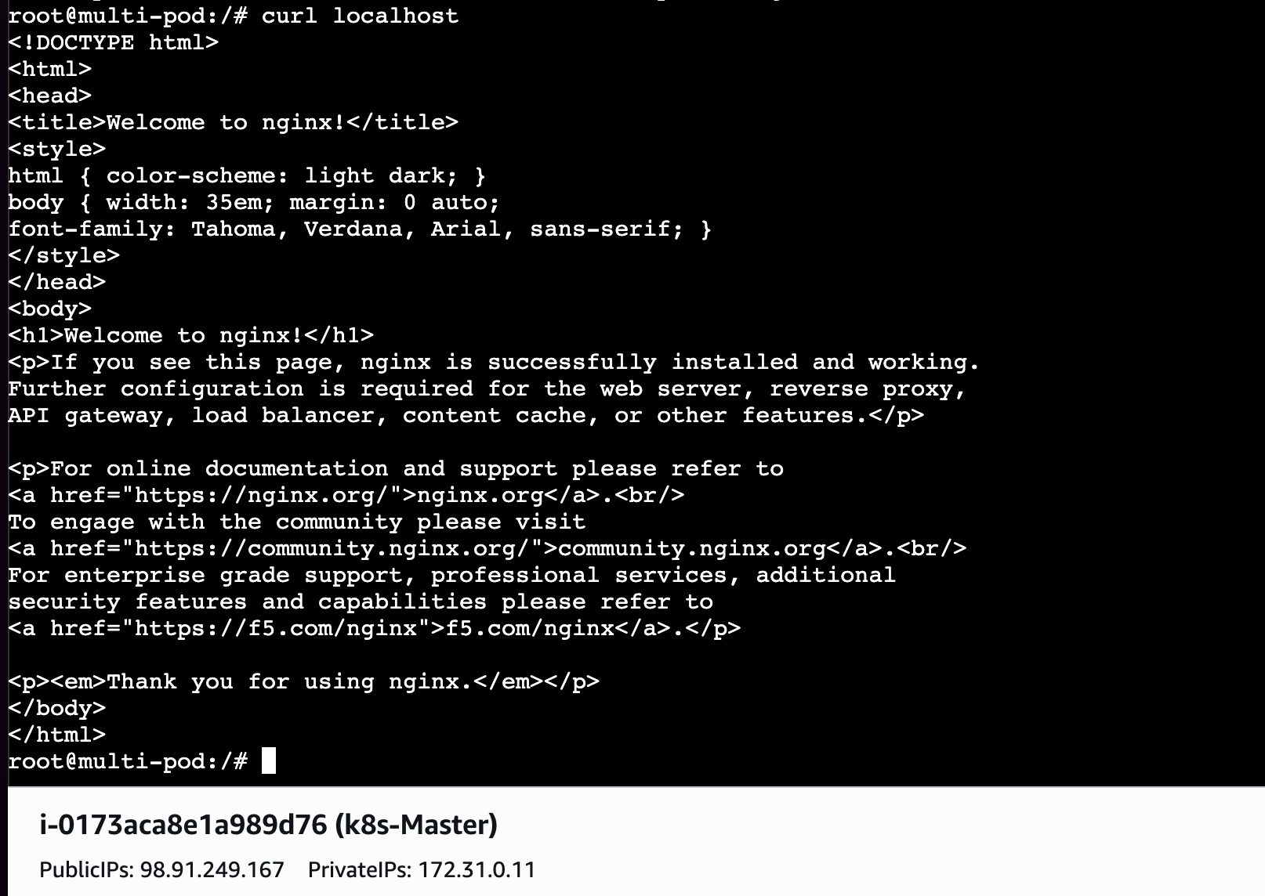

- Set Up an Init Container in a Pod Task: Modify the YAML to include an init container that sleeps for 30 seconds before the main containers start. Verify the init container's execution using kubectl describe pod and check the logs to confirm its completion.

What is an Init Container?
Init container runs BEFORE main container.
Order:
- Init container starts
- Finishes
- Main containers start

Why use it?
Common use cases:
- wait for DB
- download configs
- initialize files
- migrations

Create ⇒ vi init-pod.yaml
apiVersion: v1
kind: Pod
metadata:
name: init-pod
spec:
initContainers:
- name: init-container
image: busybox
command: ["sh", "-c", "sleep 30"]

containers:
- name: nginx
image: nginx
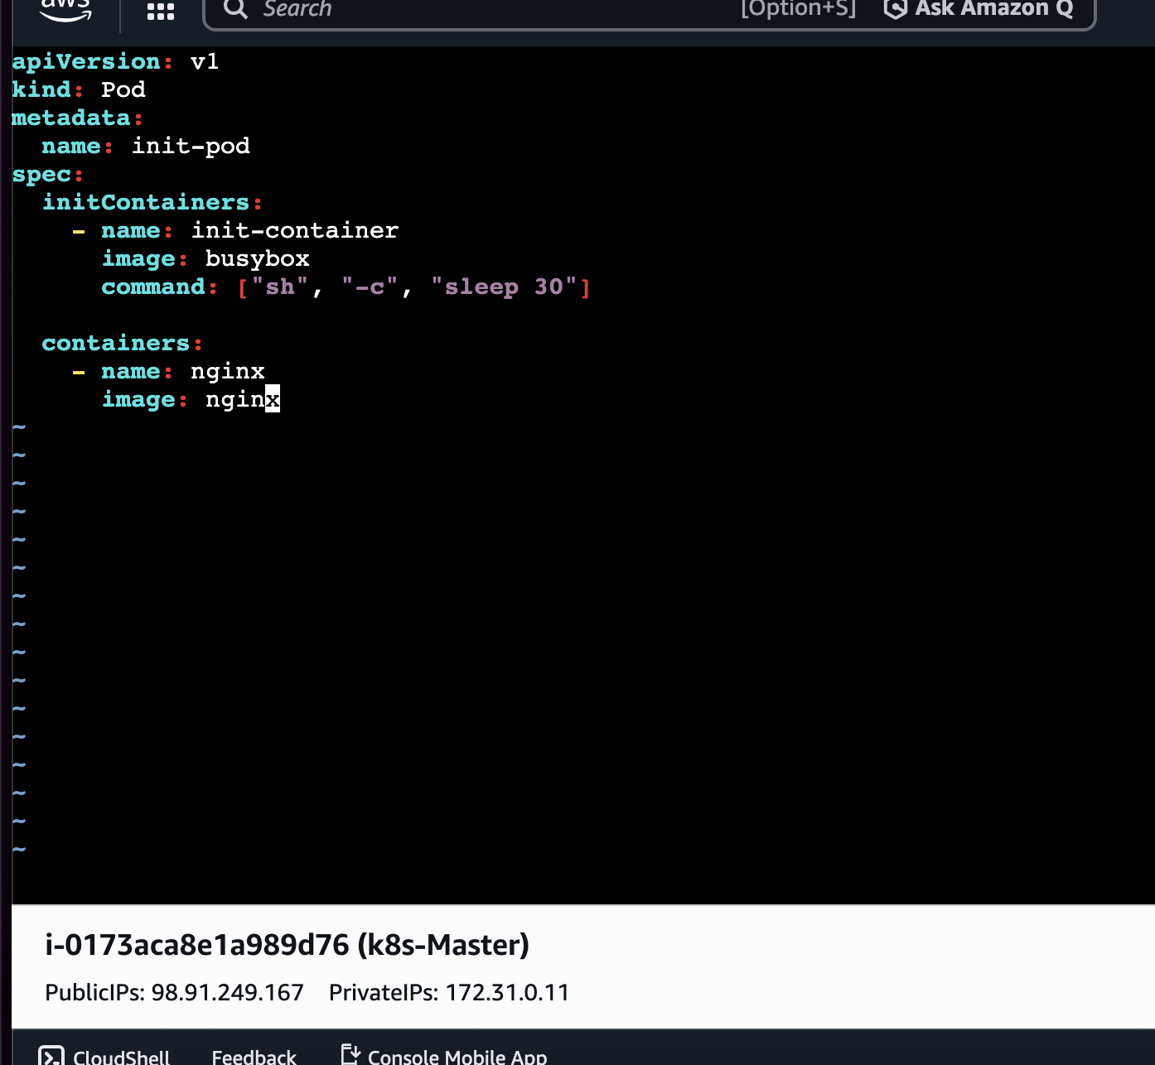

Deploy ⇒kubectl apply -f init-pod.yaml
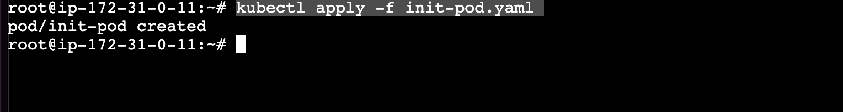
Verify ⇒ kubectl describe pod init-pod
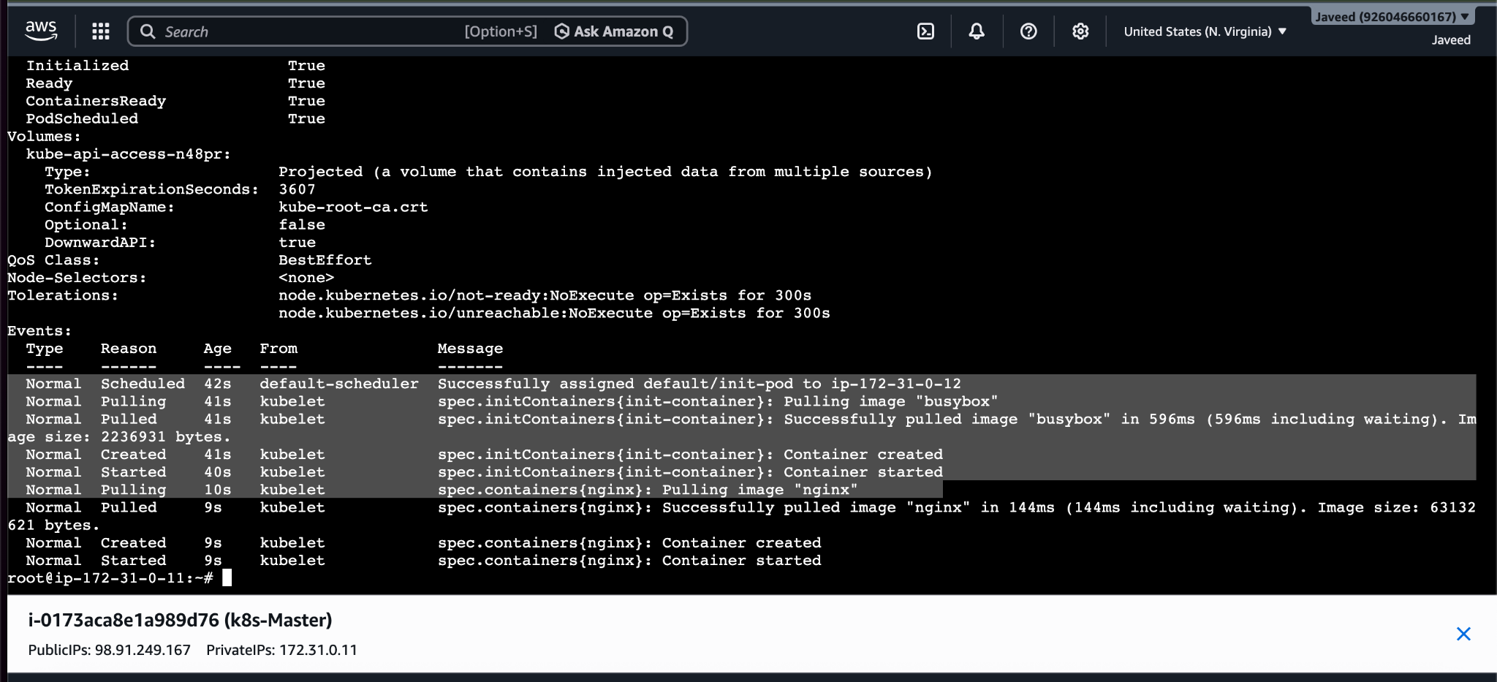

- Run a Dry Run Command to Generate YAML Task: Use the kubectl run nginx --image=nginx --dry-run=client -o yaml command to generate a Pod YAML definition. Modify the generated YAML to suit specific requirements (e.g., labels or environment variables) and deploy it.
Dry run means ⇒ Generate YAML without creating resources.

kubectl run nginx --image=nginx --dry-run=client -o yaml >nginx-dryrun.yaml ⇒ it will create a nginx-dryrun.yaml file automatically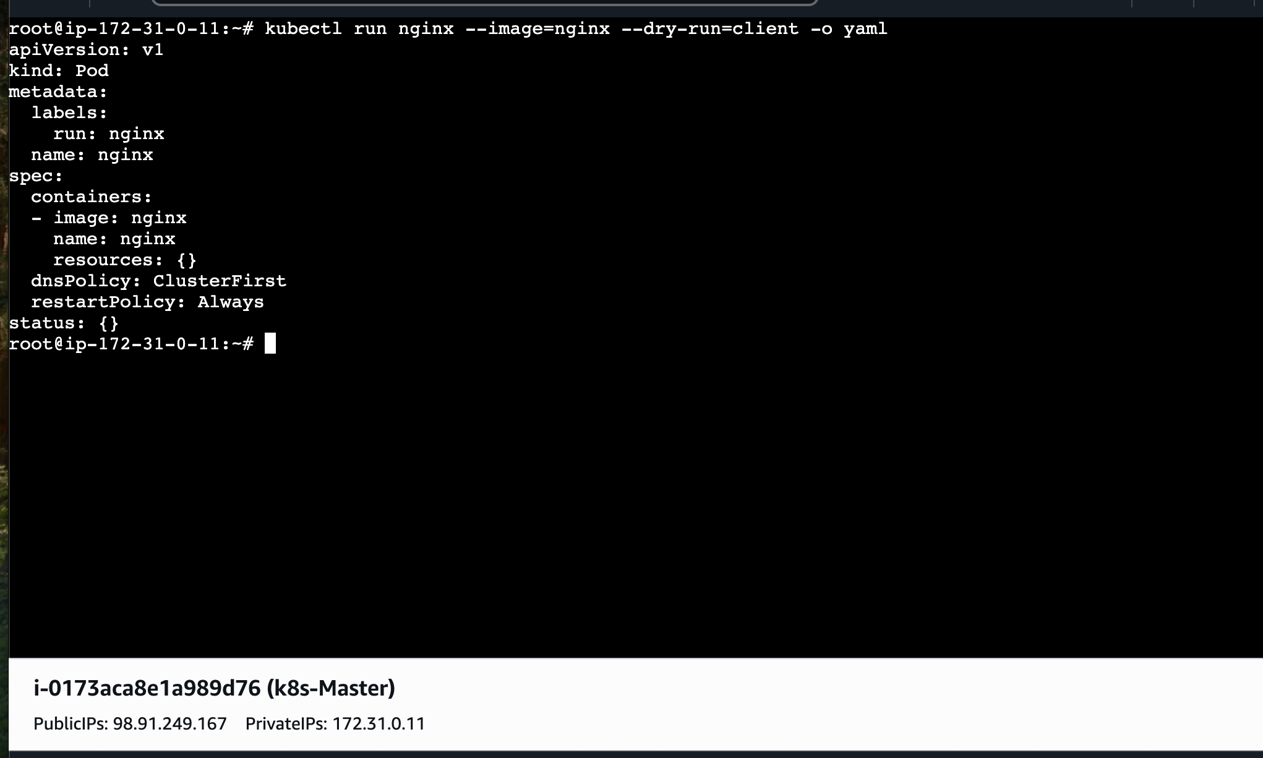
To verify ⇒ ls
Deploy ⇒ kubectl apply -f ngonx-dryrun.yaml
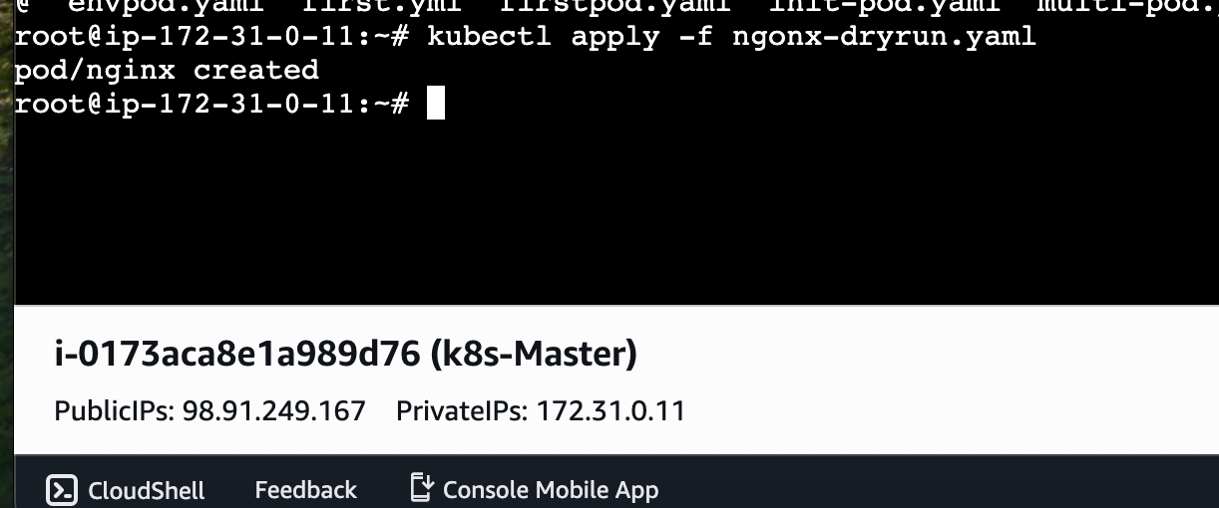

- Use kubectl apply vs kubectl create Task: Create a YAML file to define a Pod. First, deploy it using kubectl create -f <file_name>.yml and then modify the YAML (e.g., change the image version). Use kubectl apply to redeploy and verify the difference between both commands.
kubectl create ⇒ creates a new Kubernetes resource from a manifest or command. It fails if
the resource already exists.
kubectl apply ⇒ creates a Kubernetes resource if it doesn't exist, or updates the existing
resource to match the configuration in the manifest (for fields that are allowed to be
updated).

First Lets create a file with vi.pod.yaml
apiVersion: v1
kind: Pod
metadata:
name: mypod
spec:
containers:
- name: nginx
image: nginx:1.24
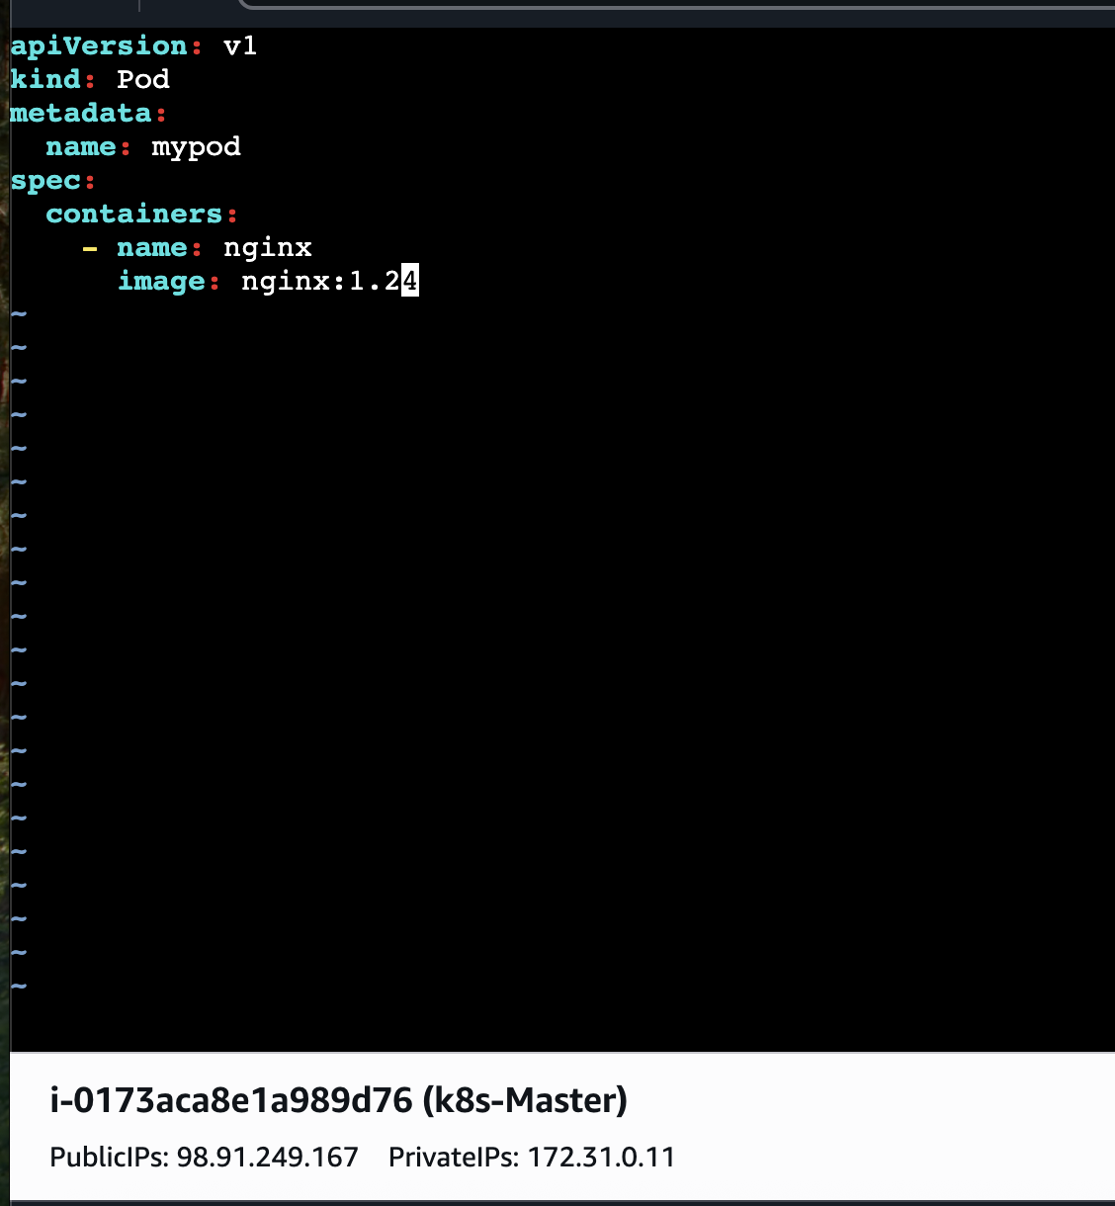
Kubect create ⇒ kubectl create -f pod.yaml ⇒ used to create a yaml file
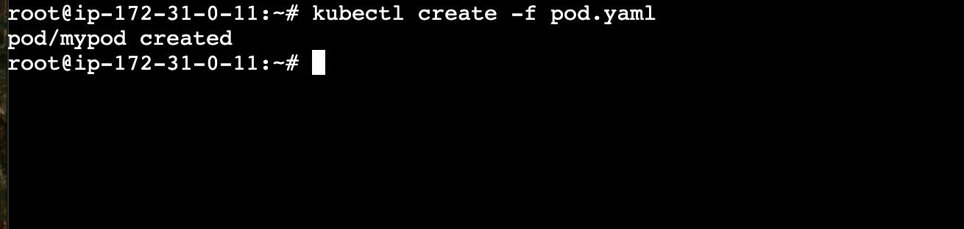

kubectl apply -f pod.yaml
If resource:
- absent → create
- present → update

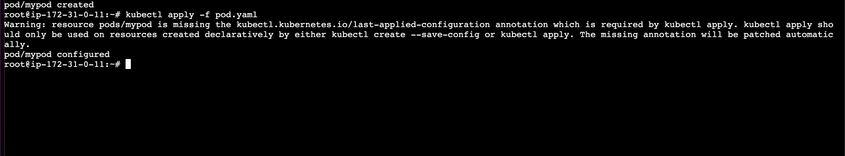

- Edit an Existing Pod Configuration Task: Use kubectl edit pod <pod_name> to modify the running Pod's environment variables or image. After making the changes, verify if they took effect by checking the container logs or environment variables using kubectl exec.
First Lets check the pods
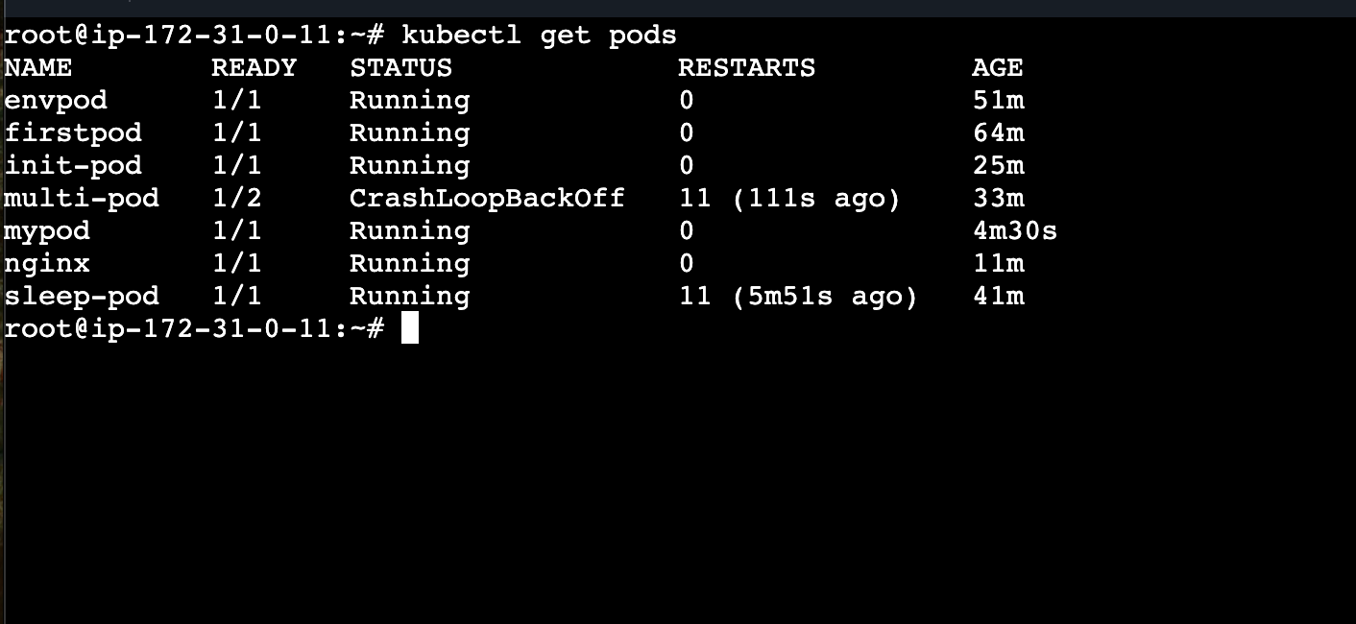
Now let edit any pod from the above pods
kubectl edit pod firstpod
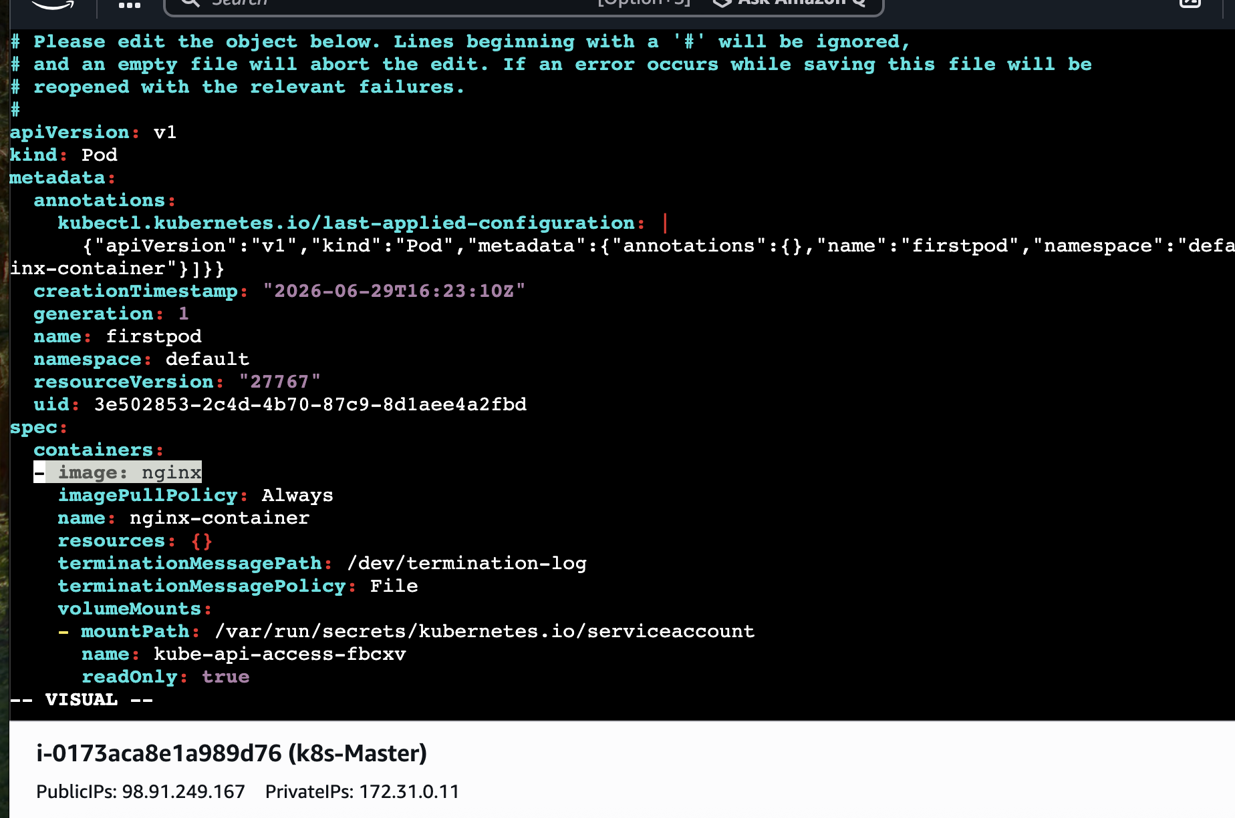
So, the image is unedited version i will be editing it to -image:nginx:latest
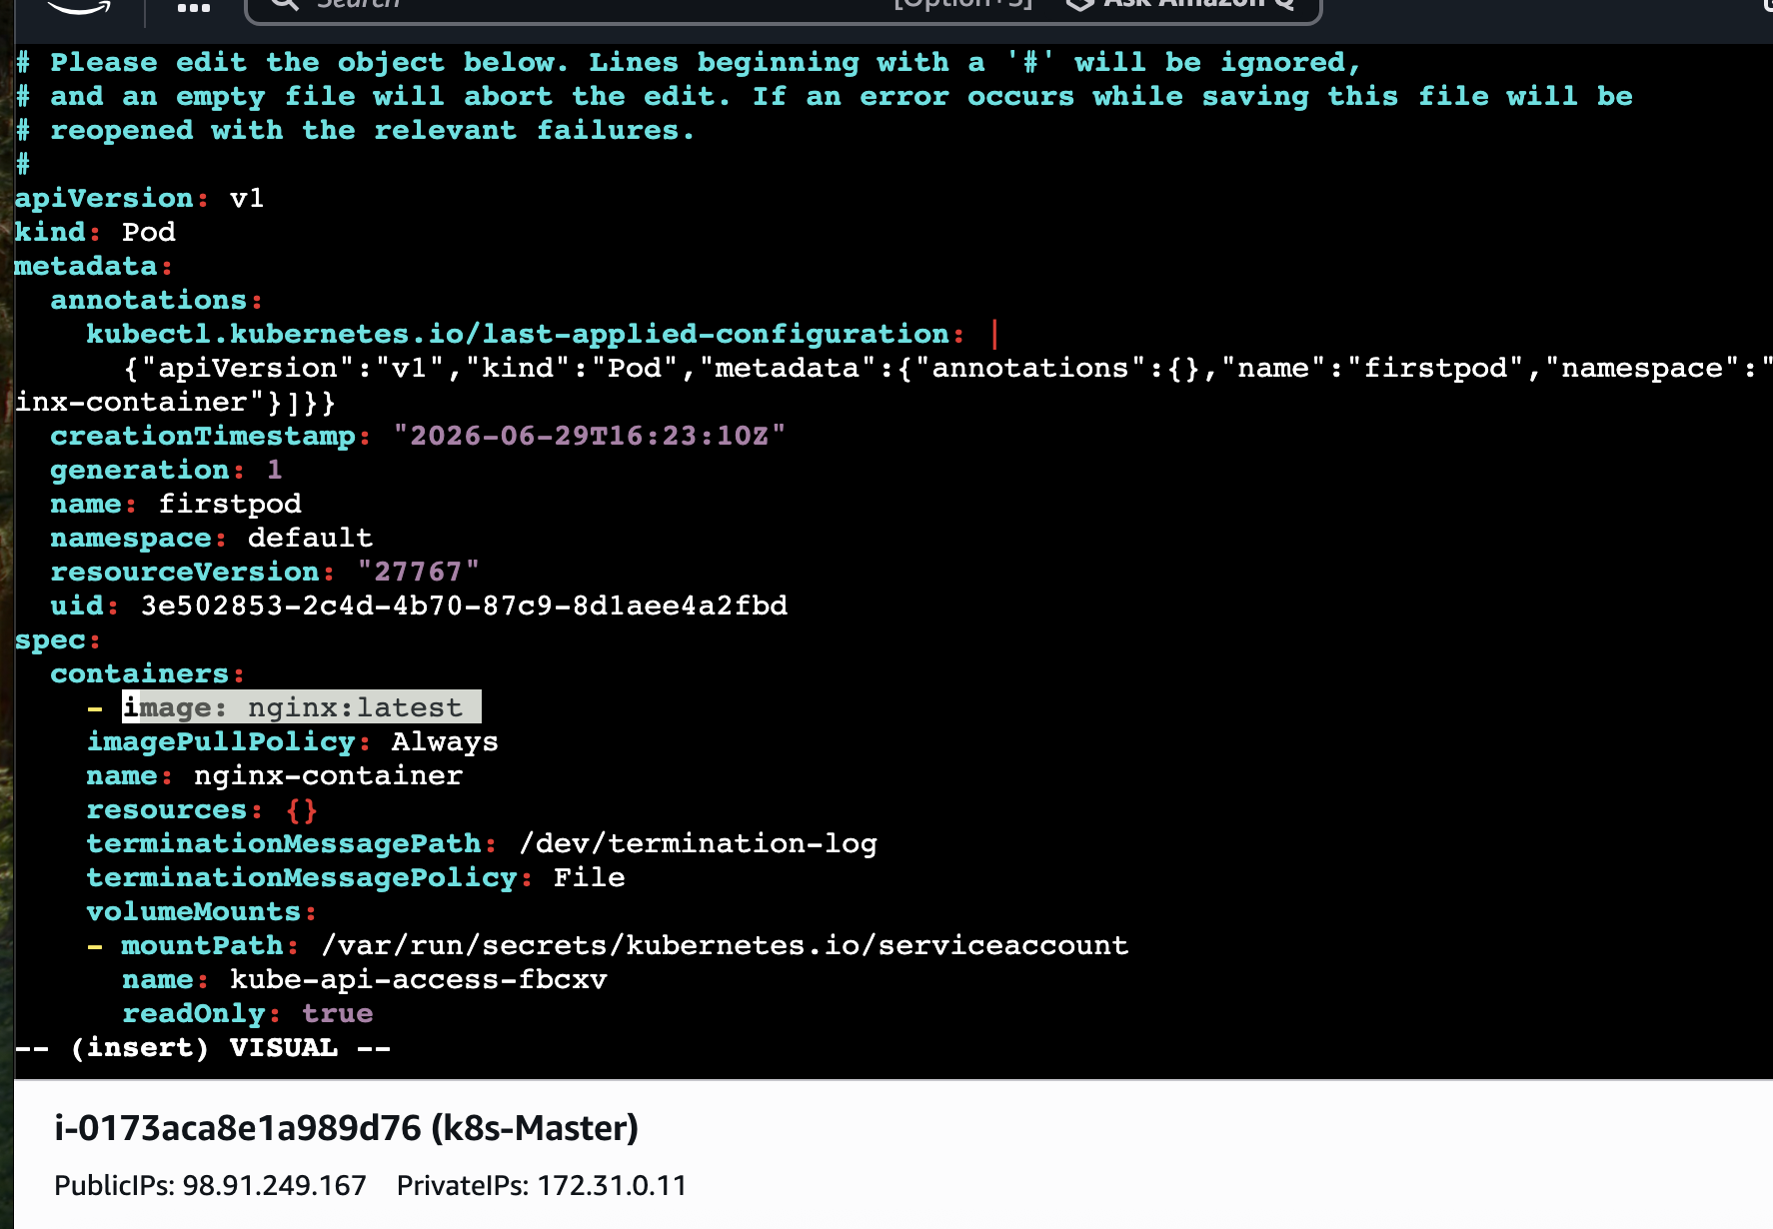
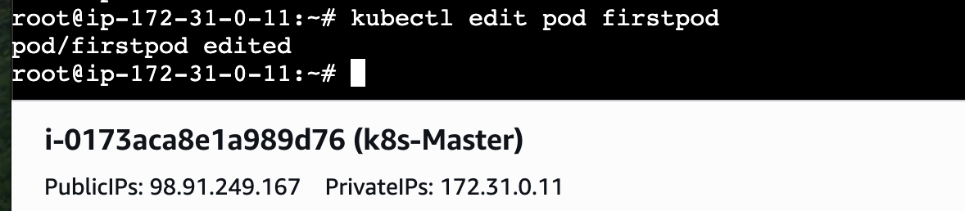
Deploy ⇒ kubectl apply -f firstpod.yaml
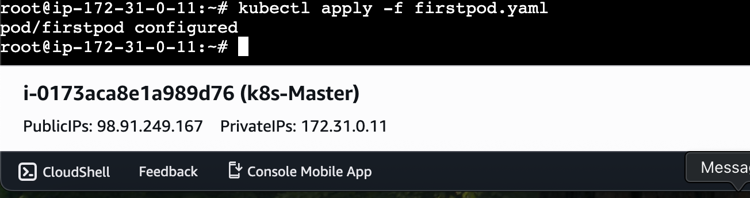
Lets Verify ⇒kubectl describe pod firstpod
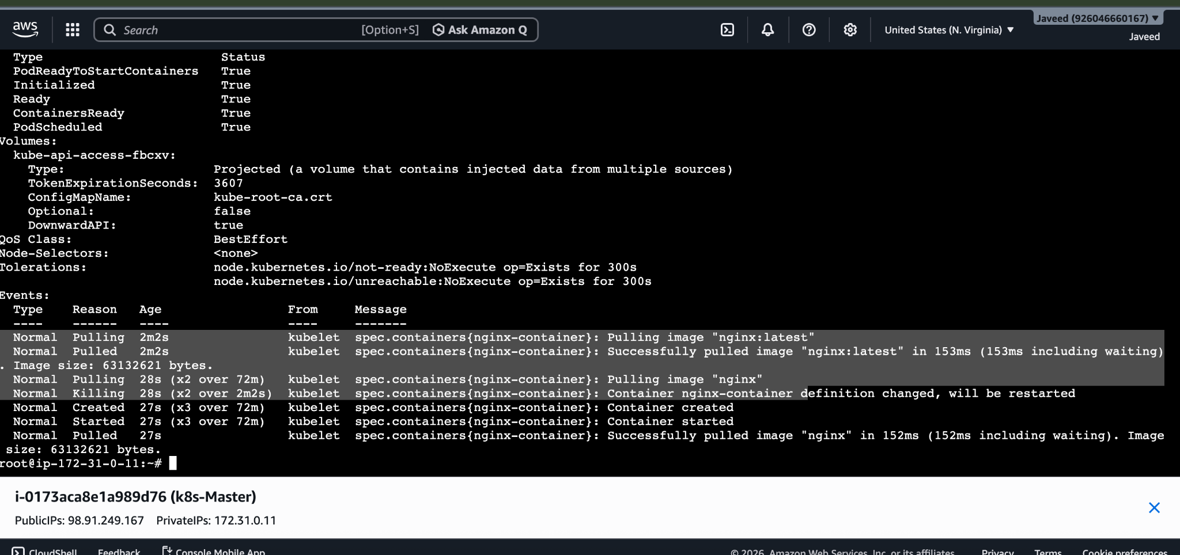
- Expose a Pod Using a Service Task: Create a YAML file to expose your firstpod using a Service (ClusterIP). Ensure that your service is exposing the Pod on port 80 and verify it using kubectl get svc.

So if there is any problem/issue then Pod IP changes when Pod restarts and Direct access is unreliable. In this case we can use Service.

What is Service?
The service provides a stable network endpoint for Pods.
Types:
- ClusterIP
- NodePort
- LoadBalancer
Lets Create ⇒ vi service.yaml
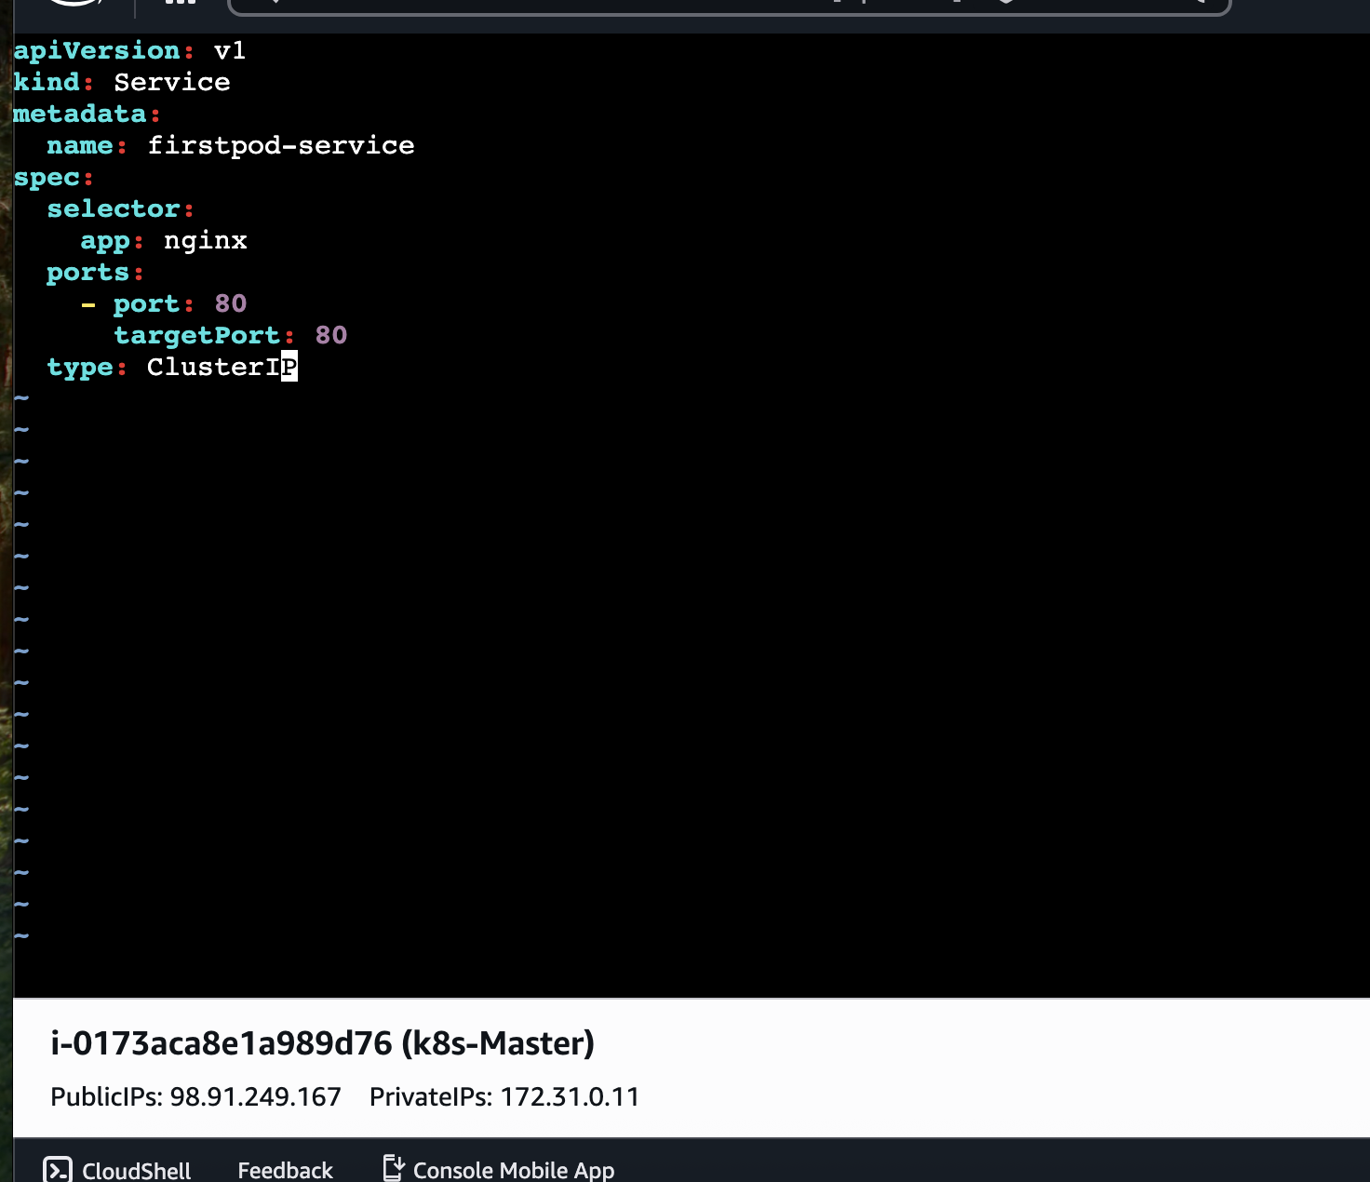

Apply and verify
kubectl apply -f service.yaml
kubectl get svc
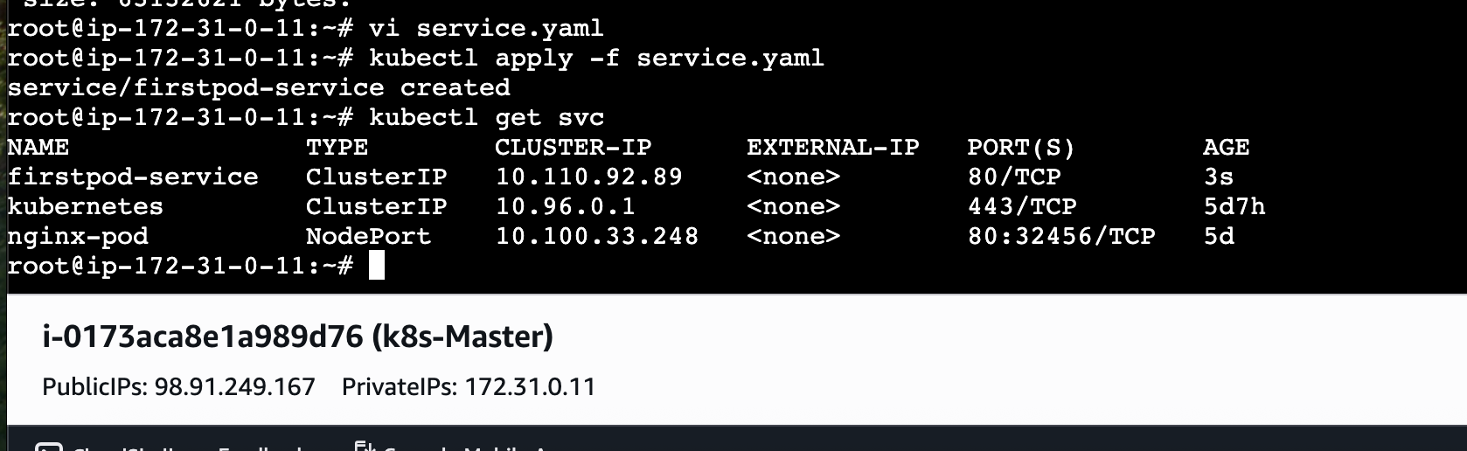

- Pod with Resource Limits and Requests Task: Add resource requests and limits to the containers in your YAML file. Specify CPU and memory requests/limits for both containers and deploy the Pod. Use kubectl describe pod to verify if the resource configurations are correctly applied.

Resource Limits and Requests Task: Mostly Used for Scheduling

Requests
Minimum resources needed.
Scheduler uses this to place Pod.
Example:
Need at least:
- 100m CPU
- 128Mi RAM

Limits
Maximum allowed.
If container exceeds:
- CPU throttled
- memory may cause OOM kill
Create ⇒ vi resource.yaml
apiVersion: v1
kind: Pod
metadata:
name: resource-pod
spec:
containers:
- name: nginx1
image: nginx
resources:
requests:
cpu: "200m"
memory: "128Mi"
limits:
cpu: "500m"
memory: "256Mi"
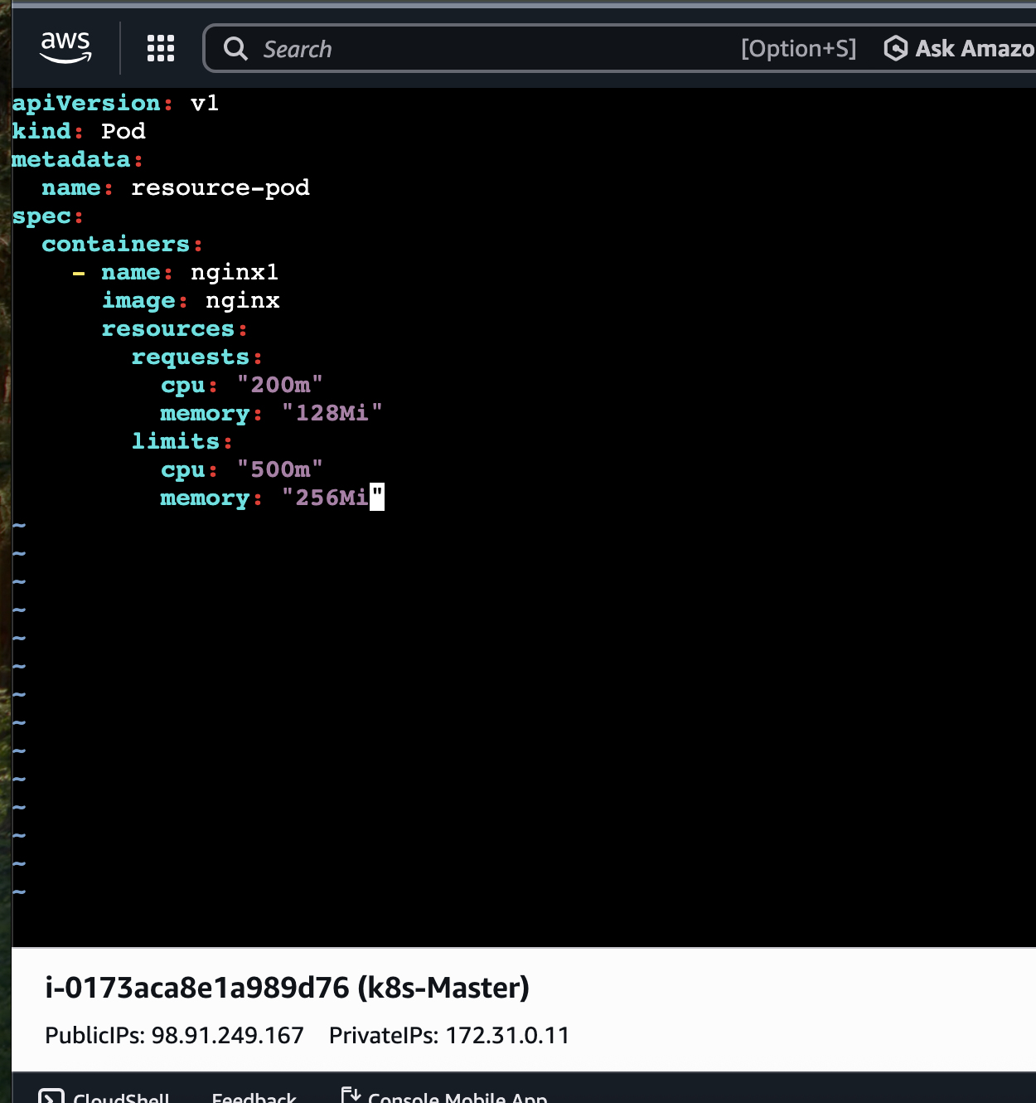
Deploy ⇒ Kubectl apply -f rescouce.yaml
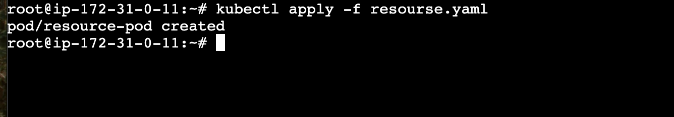
Lets Verify ⇒ kubectl describe pod resource-pod
